Goal Setting Workshop
“In absence of clearly defined goals, we become strangely loyal to performing daily acts of trivia”……. Author unknown

What did you achieve?
1.______________________________________________________________
2. ______________________________________________________________
3. ______________________________________________________________
What didn’t you achieve that you wanted to?
1.______________________________________________________________
2. ______________________________________________________________
3. ______________________________________________________________
What one thing will make the biggest difference moving forward?
_______________________________________________________________
What are your top three values?
1.______________________________________________________________
2. ______________________________________________________________
3. ______________________________________________________________
Life/Balance Wheel – where are you now?
Spiritual /10
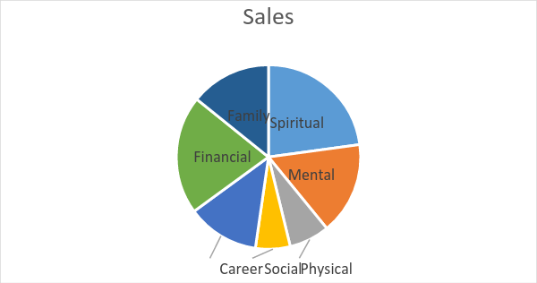
Mental /10
Physical /10
Social /10
Career /10
Financial /10
Family /10

12 month goals
Remember to keep your goals POSITIVE, PERSONAL AND PRESENT.
They must also be SPECIFIC, MEASURABLE, ACHIEVEABLE, RESULTS (VALUED) AND TIMED.
Eg. I will have completed a 5kn park run by June 30th 2017.
Goal 1: ___________________________________________________________________
Value fulfilled: _________________________ Area of life: ___________________________
Benefit 1: __________________________________________________________________
Benefit 2: __________________________________________________________________
Benefit 3: __________________________________________________________________

Goal 2: ___________________________________________________________________
Value fulfilled: _________________________ Area of life: ___________________________
Benefit 1: __________________________________________________________________
Benefit 2: __________________________________________________________________
Benefit 3: __________________________________________________________________

Goal 3: ___________________________________________________________________
Value fulfilled: _________________________ Area of life: ___________________________
Benefit 1: __________________________________________________________________
Benefit 2: __________________________________________________________________
Benefit 3: __________________________________________________________________

BAHG: ___________________________________________________________________
Value fulfilled: _________________________ Area of life: ___________________________
Benefit 1: __________________________________________________________________
Benefit 2: __________________________________________________________________
Benefit 3: __________________________________________________________________

In the next 90 days I will: 1. ______________ 2. _______________ 3. __________________

